Flexibility is the ability to move muscles and joints through their full range of movement. Flexibility can be improved by stretching.

These exercises are designed to help gently lengthen the main spinal muscles of the cervical spine.

Exercises to restore range of movement: Rotation

Start position: Sitting upright with your back supported in a chair. Position your head so it is evenly balanced, looking forward. Avoid allowing your head to tilt back, or your chin poke forwards.

Action: Gently turn your head to the right, as far as comfortable for you. You should feel a gentle stretch around the front and left side of the neck muscles. Hold for 6-10 seconds. Repeat 6-10 times. Increase as able. Return to the start position. Repeat to the other side, as demonstrated below. Work in a pain free range.

Progression: As your movement increases, you may wish to use your hand to help guide the movement a little further, whilst increasing the stretch. You may also wish to increase the time you hold the position for.
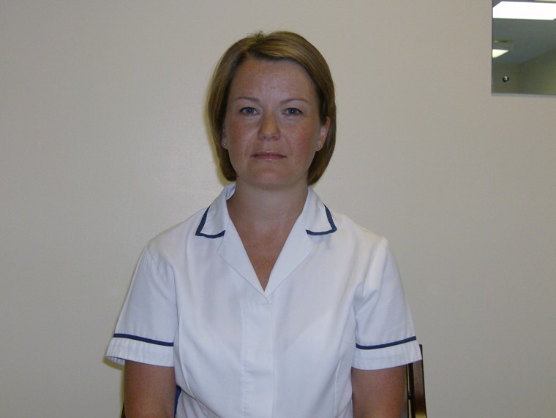

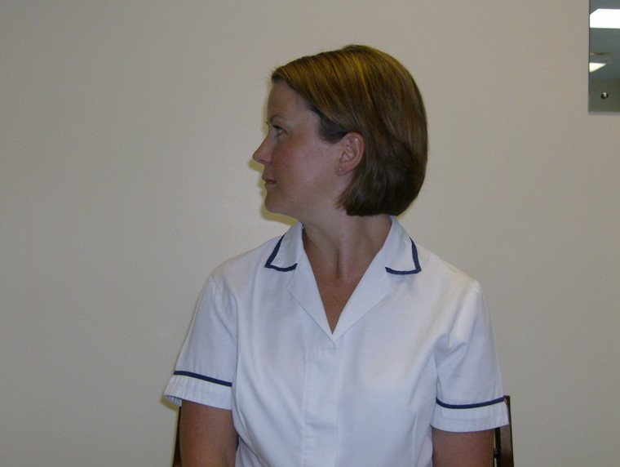

Exercises to restore range of movement: Side Flexion
Start position: Sitting upright with your back supported in a chair. Position your head so it is evenly balanced, looking forward. Avoid allowing your head to tilt back, or your chin poke forwards.

Action: Gently tip your head to the left, as far as comfortable for you. You should feel a gentle stretch along right side of the neck muscles, towards your shoulder. Hold for 6-10 seconds. Repeat 6-10 times. Increase as able. Return to the start position. Repeat to the other side, as demonstrated below. Work in a pain free range.

Progression: As your movement increases, you may wish to use your hand to help guide the movement a little further, whilst increasing the stretch. You may also wish to increase the time you hold the position for.

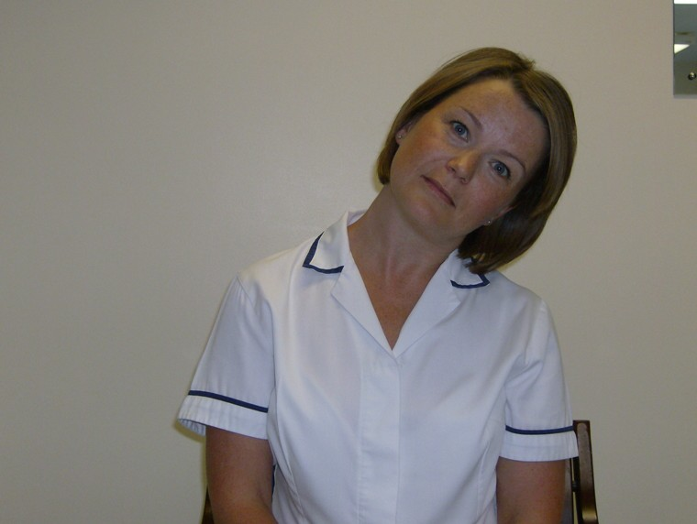

Exercises to restore range of movement: Extension

Start position: Sitting upright with your back supported in a chair. Position your head so it is evenly balanced, looking forward. Avoid allowing your head to tilt back, or your chin poke forwards.

Action: Slowly tip your head back
as far as comfortable. Avoid forcing this movement, it will improve gradually. Hold for 6 seconds, repeat 6-10 times. Increase as able.

Progression: As your movement increases, you may wish to use your hand to help guide the movement a little further. You may also wish to increase the time you hold the position for.

N.B: Do not push this exercise if you
have undergone a cervical fusion or disc replacement. Allow the movement to restored gradually, as your body allows.

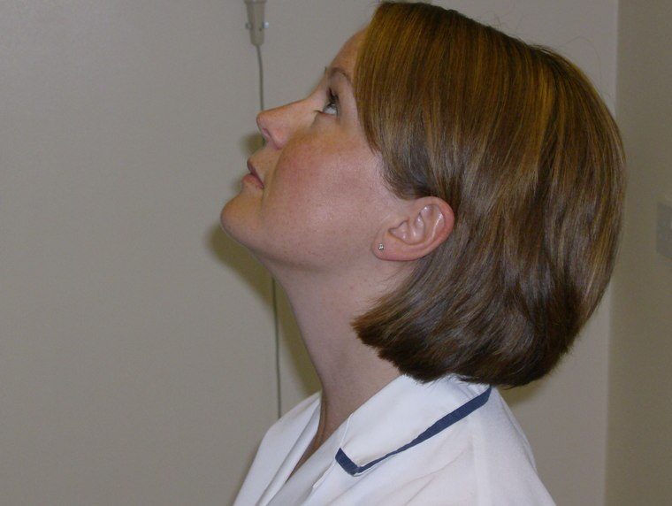

Exercises to restore range of movement: Flexion

Start position: Sitting upright with your back supported in a chair. Position your head so it is evenly balanced, looking forward. Avoid allowing your head to tilt back, or your chin poke forwards.

Action: Slowly tip your head forwards,
as far as comfortable. You should feel a gentle stretch along the back of the neck. Hold for 6 seconds, repeat 6-10 times. Increase as able.

Progression: As your movement increases, you may wish to use your hand to help guide the movement a little further, whilst increasing the stretch. You may also wish to increase the time you hold the position for.

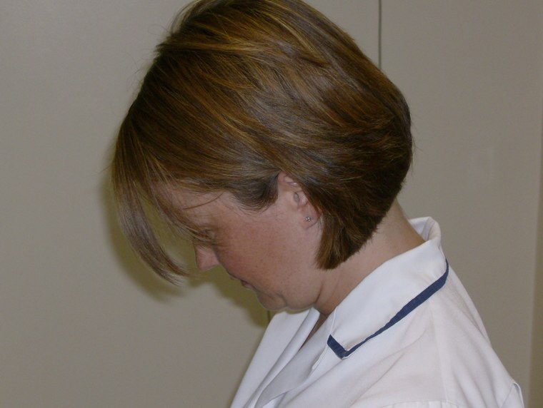

Exercises to restore range of movement in the Thoracic spine: Rotation

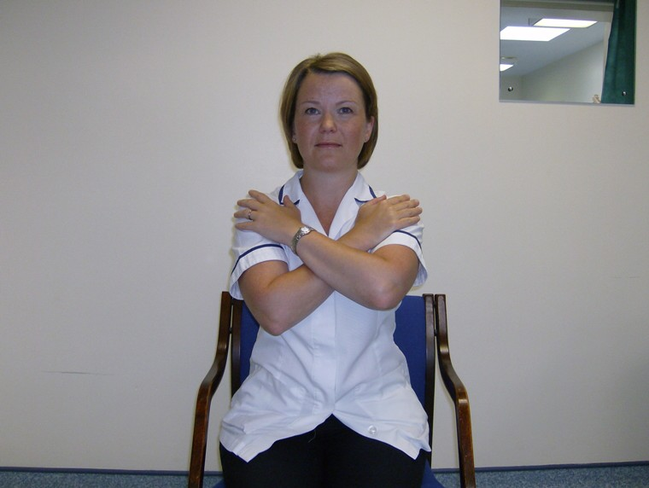
Start position: Sitting upright with your back supported in a chair. Position your head so it is evenly balanced, looking forward. Avoid allowing your head to tilt back, or your chin poke forwards.

Action: Cross both your arms over your chest, slowly turn towards the right side on your body, keeping the head in line with the trunk.
Feel a stretch on the left side of your trunk.
Hold up to 30 seconds, return to the middle,
Repeat to the opposite side.

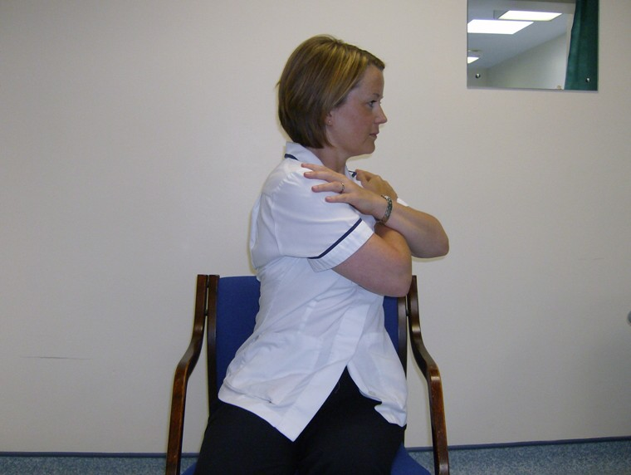

Stretches for the Cervical Spine: Upper fibres Trapezius

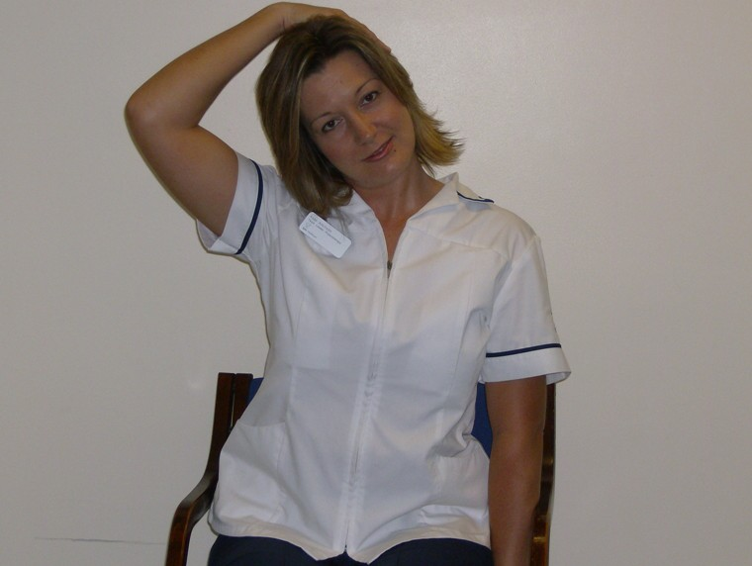
Start position: Sitting upright with your back supported in a chair. Position your head so it is evenly balanced, looking forward. Avoid allowing your head to tilt back, or your chin poke forwards.

Action: Sit on your left hand, to fix your shoulder. This will prevent you from hitching up the shoulder whilst stretching. Place your right hand onto your hand; gently draw the head to the right hand side. You should feel a stretch on the left side of your upper shoulder extending to the neck. Hold up to 30 seconds, repeating 3-5 times. You may like to gradually increase the time holding the stretch, as you feel able.

Repeat on the opposite side as shown.

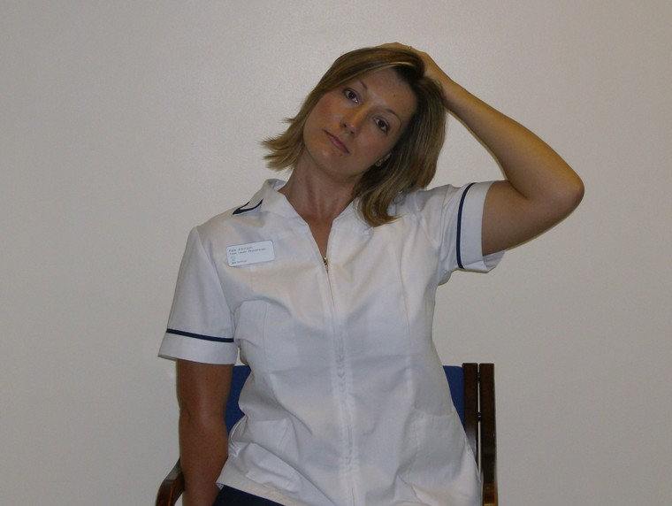

Stretch Zone

Stretches for the Cervical Spine: Scaleni
(Anterior Fibres)

Start position: Sitting upright with your back supported in a chair. Position your head so it is evenly balanced, looking forward. Avoid allowing your head to tilt back, or your chin poke forwards.

Action (Anterior Scaleni): Slowly tilt your head towards your right shoulder; hold this position whilst turning your turn your face slightly, as though looking down towards your right armpit. You should feel a comfortable stretch on the muscles around the front of the neck (Anterior Scaleni). Hold up to 30 seconds, repeating 3-5 times. You may like to gradually increase the time holding the stretch, as you feel able. Repeat on the opposite side.

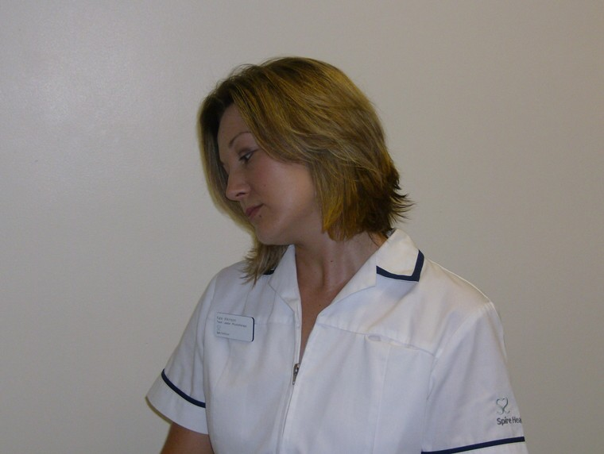

Stretch Zone

Stretches for the Cervical Spine: Scaleni
(Middle Fibres)

Start position: Sitting upright with your back supported in a chair. Position your head so it is evenly balanced, looking forward. Avoid allowing your head to tilt back, or your chin poke forwards.

Action (Middle fibres Scaleni): Slowly tilt your head towards your right shoulder; hold this position whilst lifting your chin slightly up and to the left. You should feel a comfortable stretch on the muscles around the left of side the neck. Hold up to 30 seconds, repeating 3-5 times. You may like to gradually increase the time holding the stretch, as you feel able. Repeat on the opposite side.

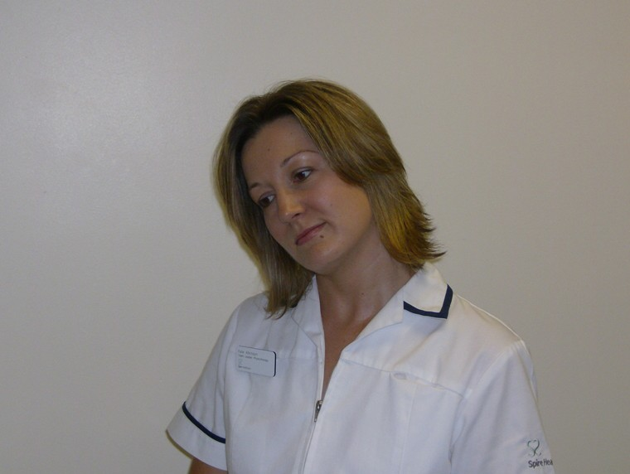
Start

Stretch Zone

Stretches for the Cervical Spine: Scaleni
(Posterior Fibres)

Start position: Sitting upright with your back supported in a chair. Position your head so it is evenly balanced, looking forward. Avoid allowing your head to tilt back, or your chin poke forwards.

Action (Posterior fibres Scaleni): Slowly tilt your head towards your right shoulder; hold this position whilst turning your head slightly, as though looking up and over your left shoulder. You should feel a comfortable stretch on the muscles around the back of the neck (Posterior Scaleni fibres). Hold up to 30 seconds, repeating 3-5 times. You may like to gradually increase the time holding the stretch, as you feel able. Repeat on the opposite side.



Stretch Zone

Stretches for the Cervical Spine: Levator Scapulae

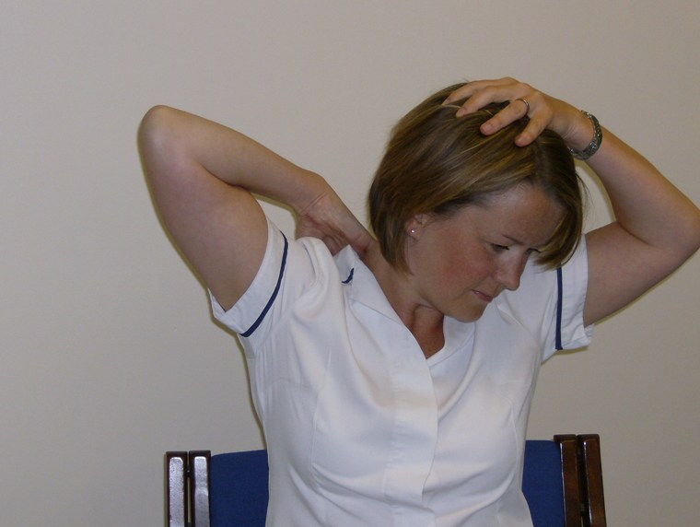
Start position: Sitting upright with your back supported in a chair. Position your head so it is evenly balanced, looking forward. Avoid allowing your head to tilt back, or your chin poke forwards.

Action (Levator Scapulae): Place your left hand on your head and position your right palm between your shoulder blades. Using your left hand, slowly tilt your head towards your right shoulder; hold this position whilst turning your head slightly, looking down towards your left armpit. You should feel a comfortable stretch on the muscles around the back and side of the neck (Levator Scapulae). Hold up to 30 seconds, repeating 3-5 times. You may like to gradually increase the time holding the stretch, as you feel able. Repeat on the opposite side.

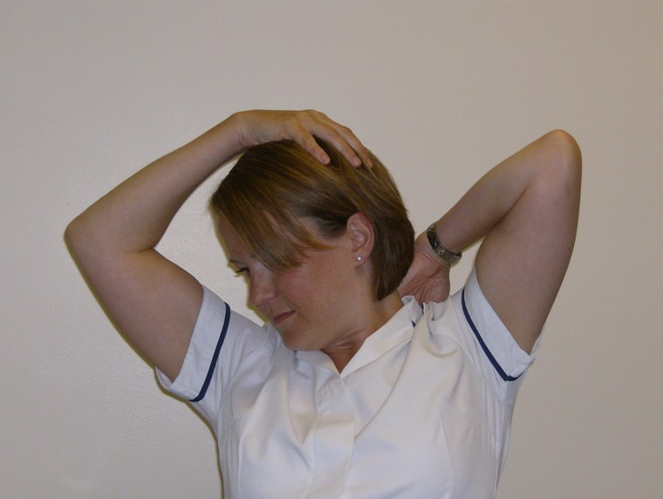

Stretch Zone

Stretches for Low Cervical and Thoracic spine: Rhomboids

Start position: Sitting upright with your back supported in a chair. Position your head so it is evenly balanced, looking forward. Avoid allowing your head to tilt back, or your chin poke forwards.

Action (Rhomboids): Cross your left leg over the right, allow the knee fall out to the side. Rest your left elbow onto the left knee and hold around your left ankle with your left hand. Try to gently hitch up your left shoulder towards your left ear, without allowing the contact between elbow and knee to be lost. Feel a comfortable stretch on the muscles around the inside of the shoulder blade (Rhomboids). Hold up to 30 seconds, repeating 3-5 times. You may like to gradually increase the time holding the stretch, as you feel able. Repeat on the opposite side.

Alternative: Clasp your hands in front, with your arms out stretched and try to pull your shoulder blades apart.
Hold up to 30 seconds, repeating 3-5 times.

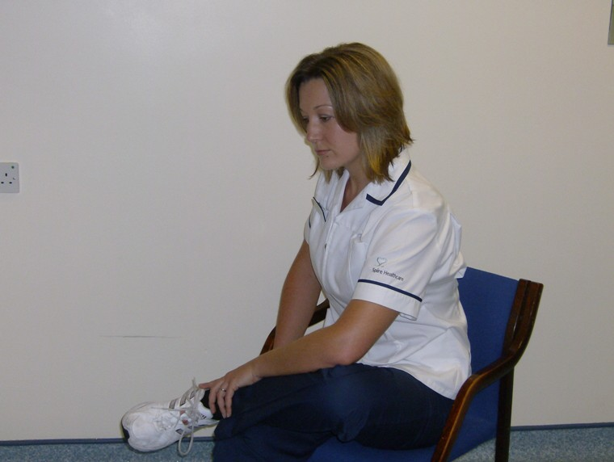

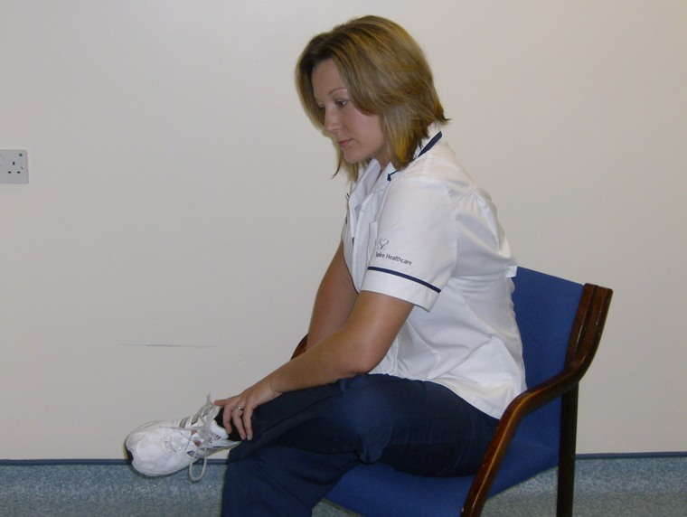

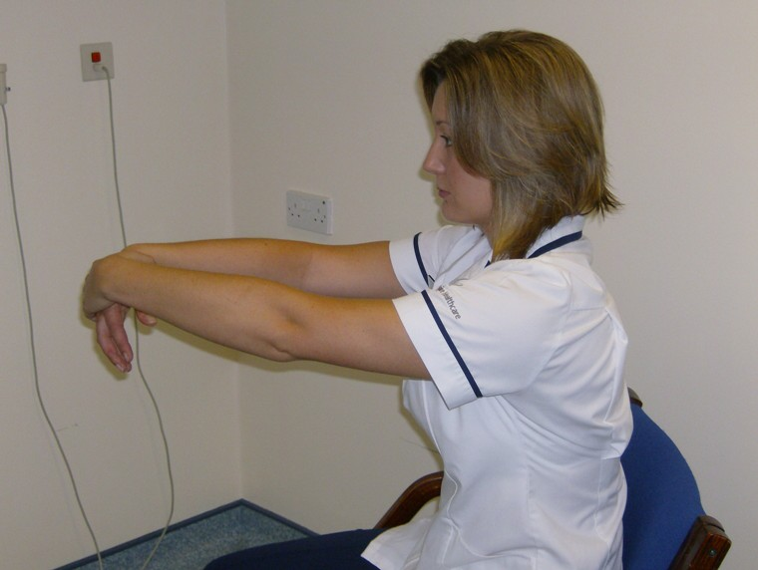
Stretch Zone

Stretches for Chest wall: Pectorals (Major & Minor)

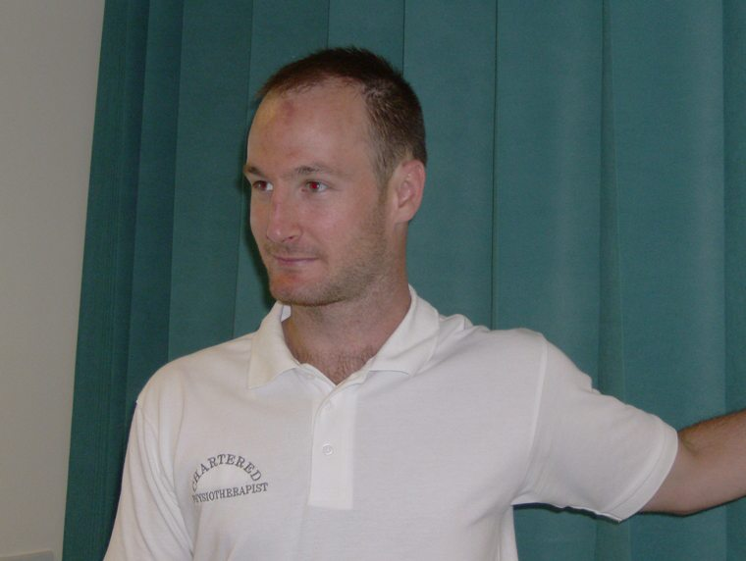
Start position: Standing upright looking forwards. Position your head so it is evenly balanced. Avoid allowing your head to tilt back, or your chin poke forwards.

Action (Pectorals): Place your left arm in the corner of a door way, with the arm slightly bent. Step forwards with your opposite leg, feeling the stretch across the front of your left side / chest. Hold up to 30 secs, repeat 3- 5 times. Repeat on the opposite side.

Alternative: In lying position your arms at right angles to your body. Drop your knees over to the left hand side, feel a stretch in the right side of your chest. Hold up to 30 secs. Return your knees to the centre, repeat to the opposite side. Hold up to 30 seconds. Repeat 3-5 time each way.

Stretch Zone

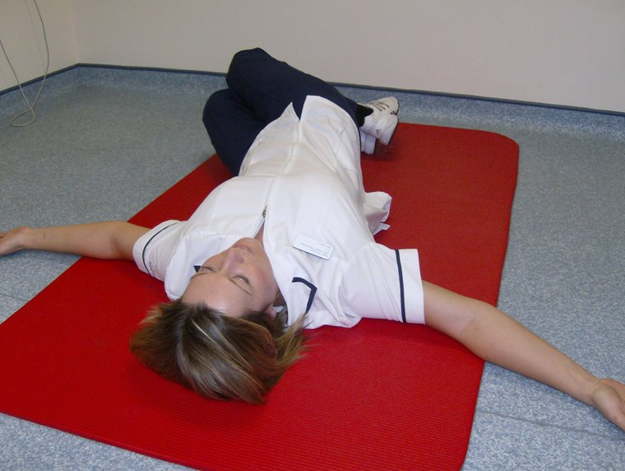

Stretch Zone

Cervical strengthening & stability exercises: Deep Neck Flexors (Supine)

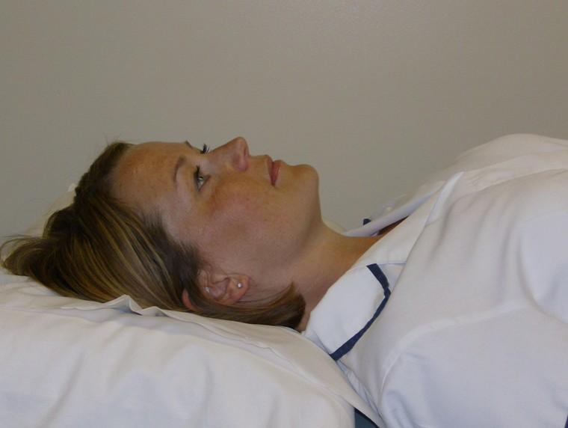
Start position: Lying down, with your head supported on a firm pillow, so it is positioned in the middle, evenly balanced. Avoid allowing your head to tilt back, or your chin poke forwards.

Action: Gently tuck your chin into your neck, as though you are trying to hold an orange under your chin. Hold the position for 6 seconds. Repeat 6-10 times, 3 times per day. As you become stronger try to hold the action for longer periods, or perform more repetitions.

When this is very easy progress the exercise to an upright position (See next exercise)

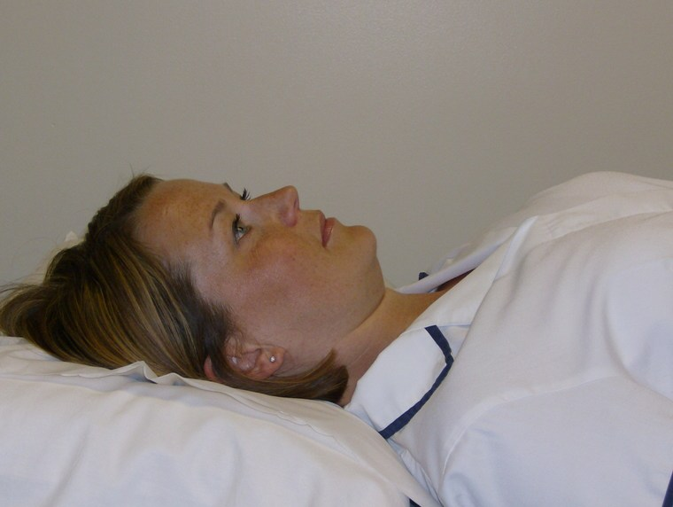

Cervical strengthening & stability exercises: Deep Neck Flexors (Standing)

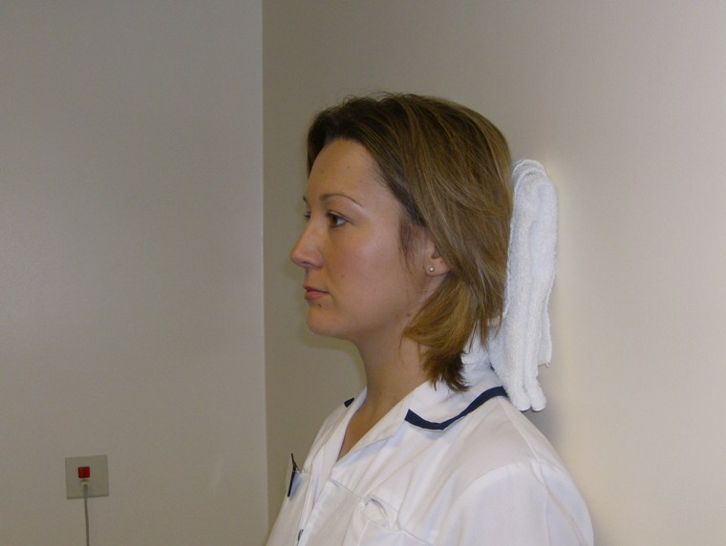
Start position: Standing against a wall or door, with your head supported on a small hand towel, so it is positioned in the middle, evenly balanced. Avoid allowing your head to tilt back, or your chin poke forwards.

Action: Gently tuck your chin into your neck, as though you are trying to hold an orange under your chin. Hold the position for 6 seconds. Repeat 6-10 times, 3 times per day. As you become stronger try to hold the action for longer periods, or perform more repetitions.

When the exercise becomes easy progress to the next level, see below.

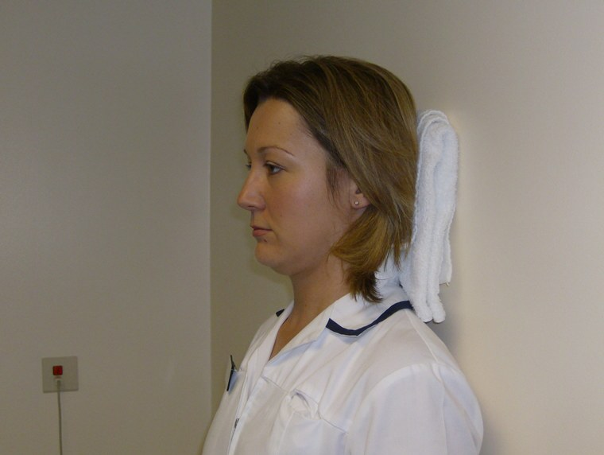

Cervical strengthening & stability exercises: Deep Neck Flexors (Four Point Kneeling)

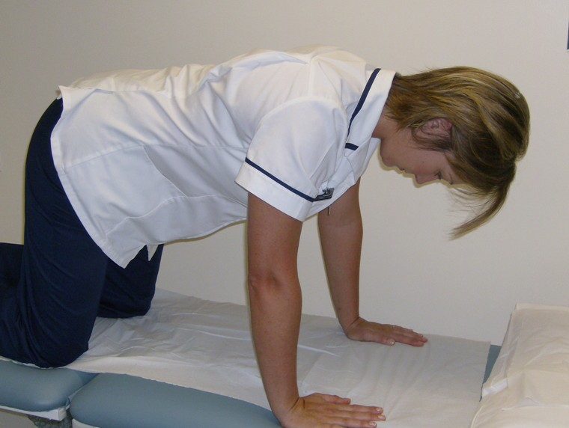

Start position: Position yourself on all fours on the floor. Hold your head so it is positioned in the middle, evenly balanced. Avoid allowing your head to tilt back, or your chin poke forwards.

Action: Gently tuck your chin into your neck, as though you are trying to hold an orange under your chin. Hold the position for 6 seconds. Repeat 6-10 times, 3 times per day. As you become stronger try to hold the action for longer periods, or perform more repetitions.

When this becomes easier you may wish to try holding this position while raising an arm or a leg, to challenge your balance further (See lumbar spine core stability exercises)

Shoulder Girdle Stability Exercises: Serratus Anterior

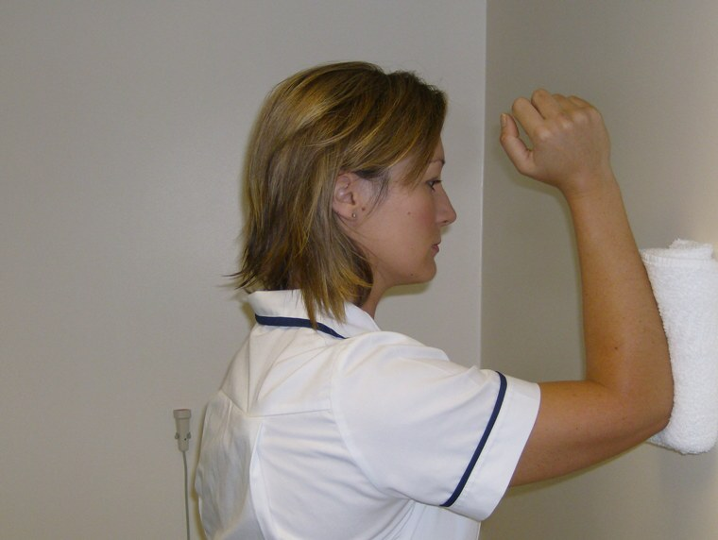
Start position: Standing facing a wall or door, with your head it is positioned in the middle, evenly balanced. Avoid allowing your head to tilt back, or your chin poke forwards. Place a small hand towel onto the wall and rest your right elbow and forearm onto it.

Action: Keeping your body still and maintaining good head posture perform a static contraction of the shoulder girdle muscles. Do this by gently pushing the elbow into he towel, as thought you are trying to pull the shoulder blade around the rib cage. Hold the contraction for 6 -10 seconds initially, repeating 6-10 times , 3 times per day. As you become stronger increase the hold duration or repetitions.

N.B: Often after Cervical pain or surgery the muscles of the shoulder girdle can become weakened. If they are not strengthened appropriately, this can lead to associated shoulder dysfunction.

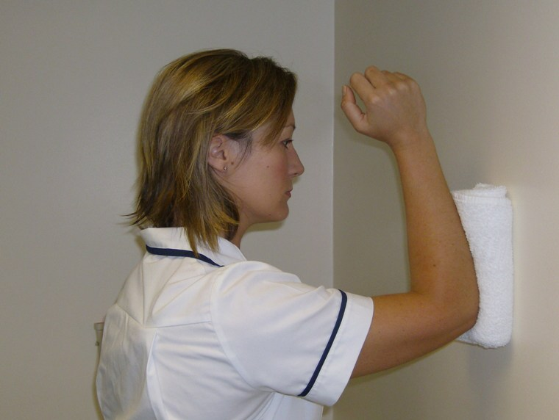

Posture Awareness

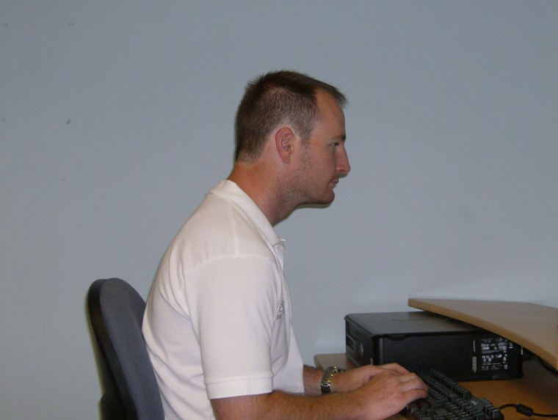
BAD!

When sitting at your PC avoid a slouched posture, with your chin poking forwards and shoulders slumped.

GOOD!

When sitting at your PC, try to ensure your head is positioned in the middle of your body, resting evenly on your shoulders. The chair in which you sit should support the small of your back; your hips should be slightly higher than your knees, your elbows resting at your sides, with wrists relaxed. Ensure the monitor is directly in front of you; any mouse positioned just to the side, so you do not have a stretch to reach it. Try not to sit for lengthy periods, as this does not encourage good tissue health. Try to move every 40 minutes where possible.



